**A Report on**

**Unveiling The Virtual Classroom:**

**An In-Depth Analysis Of The Online Education**

**System**

**Category: Data Analytics**

**Name: Bharti Khemani**

**College: A. P. Shah Institute of Technology, Thane**

**August 2023**

**Outline**

1. **Introduction**
2. **Project Details**
3. **Implementation**
4. **Results**
5. **Conclusion**

# Introduction

Online classes and technology have emerged as a superhero during the lockdown days. We have all been under house arrest but are still connected with the world of education. Due to the lockdown, students have not been able to stay connected with the outer world and the lack of exposure is evident. The only reprieve for the students’ mental well-being has been the transition to online classes. Teachers made sure that the learning for students was not compromised, so they took a great leap forward to find solutions and create new learning environments for their students to ensure that learning never stops. With the rapid advancements in technology and the widespread availability of internet access, online education has gained significant popularity in recent years.

This project aims to delve deep into the various aspects of online education, examining its strengths, weaknesses, opportunities, and challenges. The outcomes of this project will provide valuable insights for educational institutions, policymakers, and online learning platforms to enhance the effectiveness and accessibility of online education. This analysis of the online education system aims to contribute to the ongoing dialogue on the future of education and help shape a more inclusive, engaging, and effective learning environment in the digital age.

# Project Details

This would include taking student and teacher surveys, understanding student needs , and having an efficient feedback system. There is a need to update the content that is being taught to students based on the feedback .These requirements are necessary to ensure that students are able to find it easy to adjust with online education / e-learning. Specific requirements may vary depending on the student demographic, their needs and their interests

**Social Impact:** Understanding the pros and cons of e-learning and making it better for future generations

**Business Model/Impact:** Ed-tech companies and other organizations can capitalize on this

**Skills Required:**

* Python,
* Python For Data Analysis,
* Python For Data Visualization,

# Implementation

* Exploratory Data Analysis,

|  |  |  |
| --- | --- | --- |
| Fig: Sample image for project work flow  Step 1: **Collect The Dataset**  1.1: Understand the data  Data contains all the meta information regarding the columns described in the CSV files.  Dataset used: [ONLINE](https://drive.google.com/file/d/1O39CDVV9CkPthvNO7z2GHbyxRPKm2Ey6/view?usp=sharing) [EDUCATION](https://drive.google.com/file/d/1O39CDVV9CkPthvNO7z2GHbyxRPKm2Ey6/view?usp=sharing) [SYSTEM](https://drive.google.com/file/d/1O39CDVV9CkPthvNO7z2GHbyxRPKm2Ey6/view?usp=sharing) [REVIEW.csv](https://drive.google.com/file/d/1O39CDVV9CkPthvNO7z2GHbyxRPKm2Ey6/view?usp=sharing)  **Column Description for Online education system review:**   |  |  | | --- | --- | | 1. *Gender: Gender of the student* 2. *Home Location : Rural or Urban.* 3. *Level of Education : UG, PG or school* 4. *Age : age of the student* | 1. *Number of subjects :* 2. *Device Type Used : device used to attend the online classes* 3. *Economic status : economic status of the family* | |

* IBM Cognos Analytics
  1. *Internet facility in your locality*
  2. *Are you involved on any sports*
  3. *Family Size*
  4. *Do elderly people monitor you ?.*
  5. *Study Time(hours)*
  6. *Sleep time (hours)*
  7. *Time spent on social media(hours)*
  8. *Interested in gaming ?*
  9. *Have a separate room for studying ?*
  10. *Engaged in group studies ?*

Step 2: **Connect The Data With IBM Cognos**

**Database Connection**

* 1. *Average marks scored before pandemic in traditional classroom*
  2. *Your interaction in online mode 20. Clearing doubts with faculties online ?*

1. *Interested in ?*
2. *Performance in online*
3. *Your level of satisfaction in online education*

Login to IBM Cognos, Launch IBM Cognos, now go to the prepare **data** section, click on upload option and upload the csv file

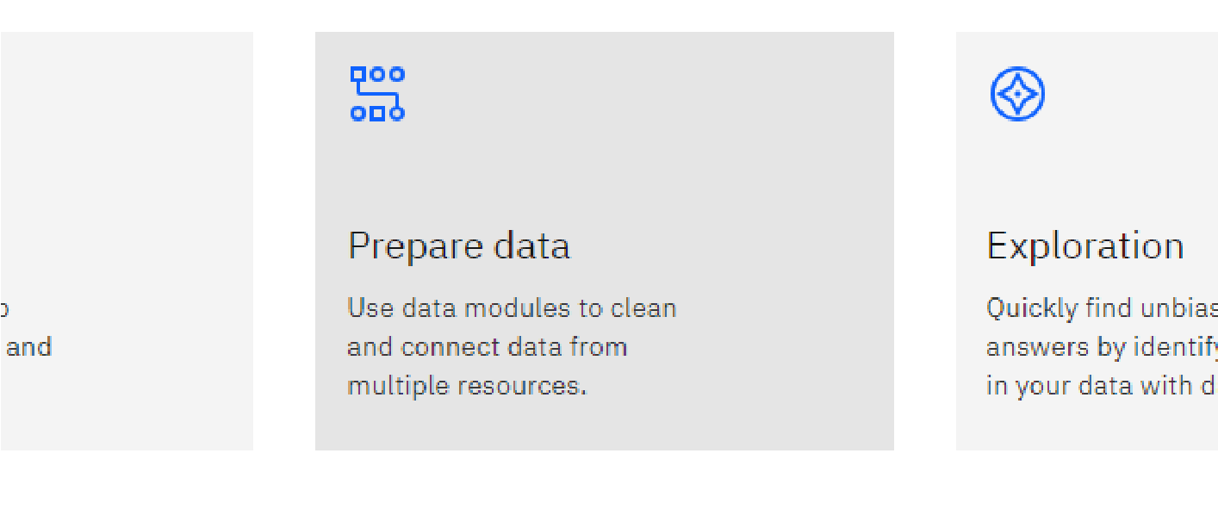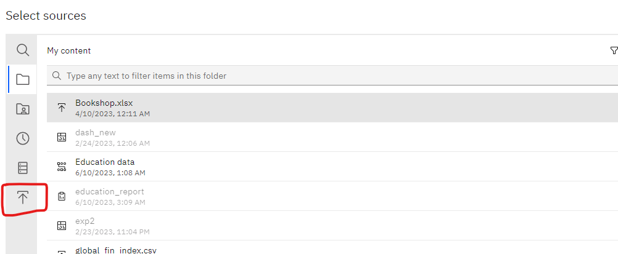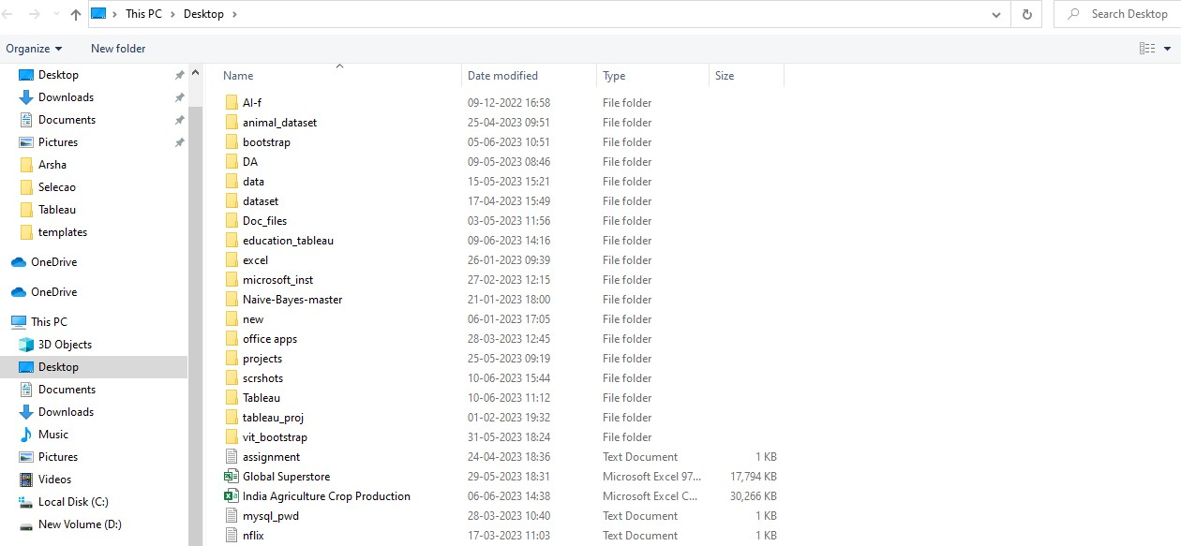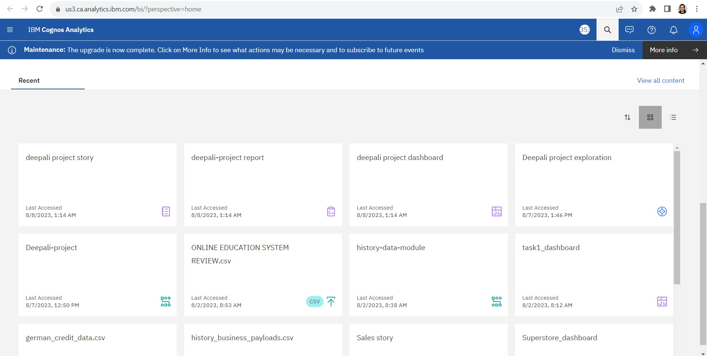

**Prepare The Data For Visualization**

Preparing the data for visualization involves cleaning the data to remove irrelevant or missing data, transforming the data into a format that can be easily visualized, exploring the data to identify patterns and trends, filtering the data to focus on specific subsets of data, preparing the data for visualization software, and ensuring the data is accurate and complete. This process helps to make the data easily understandable and ready for creating visualizations to gain insights into the performance and efficiency.

Data preprocessing can be performed in many ways using many different steps depending on your data here, we are going to do some part of data preparation on our data.

Once you upload the data into the data module, you will encounter the interface shown in the below image

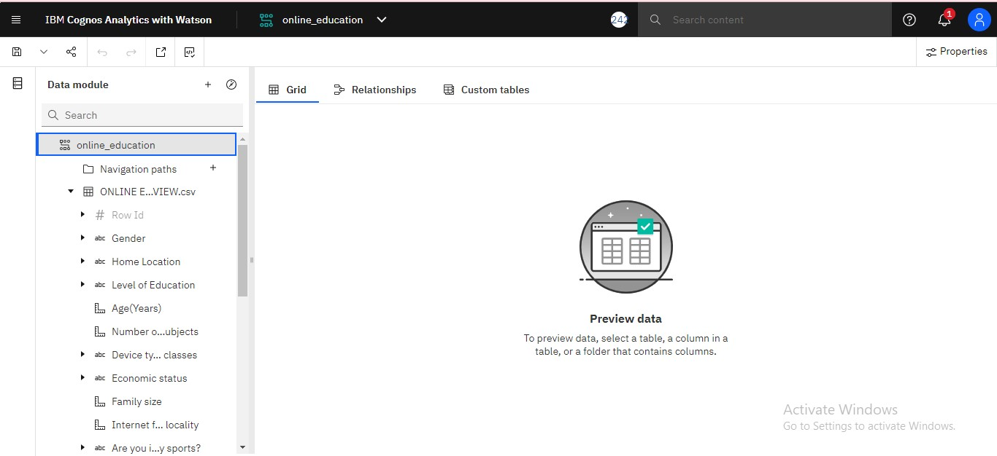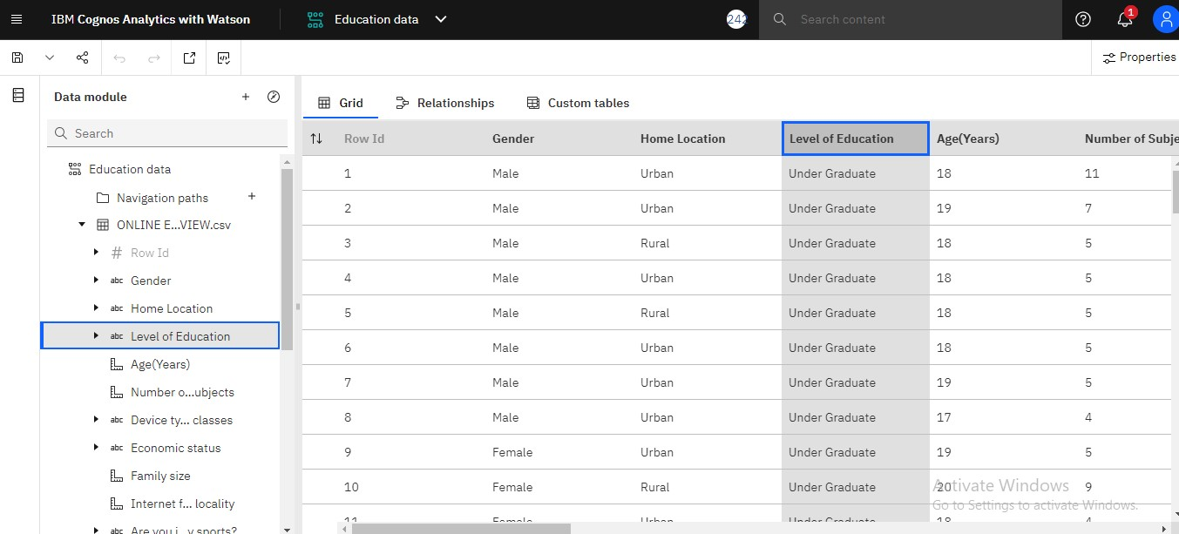

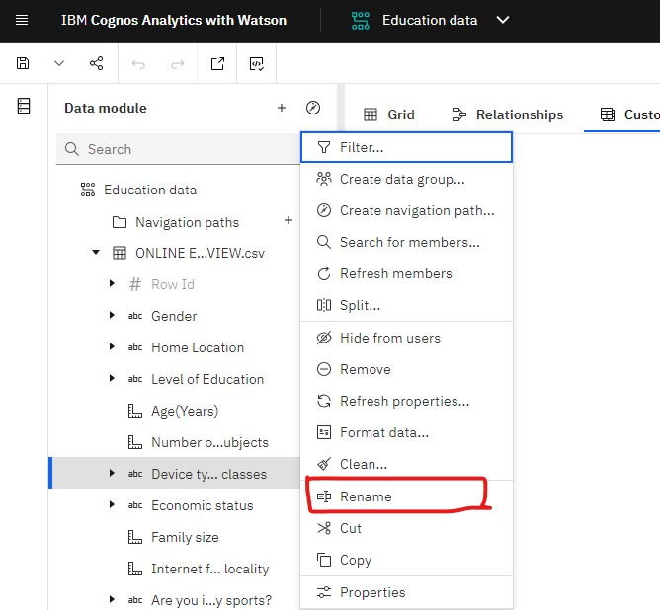



Data Visualization

Data visualization is the process of creating graphical representations of data in order to help people understand and explore the information. The goal of data visualization is to make complex data sets more accessible, intuitive, and easier to interpret. By using visual elements such as charts, graphs, and maps, data visualizations can help people quickly identify patterns, trends, and outliers in the data. **No Of Unique Visualizations**

The number of unique visualizations that can be created with a given dataset. Some common types of visualizations that can be used to analyze the online education data include bar charts, line charts, heat maps, scatter plots, pie charts, Maps etc. These visualizations can be used to compare performance, track changes over time, show distribution, and relationships between variables, breakdown of revenue and customer demographics, workload, resource allocation and location of hotels.

**Activity 1.1: Column Chart:**

A Column chart can compare the data across different categories. The height of the bars represents the measured value of each category. It can be represented as vertical and horizontal type bar charts.

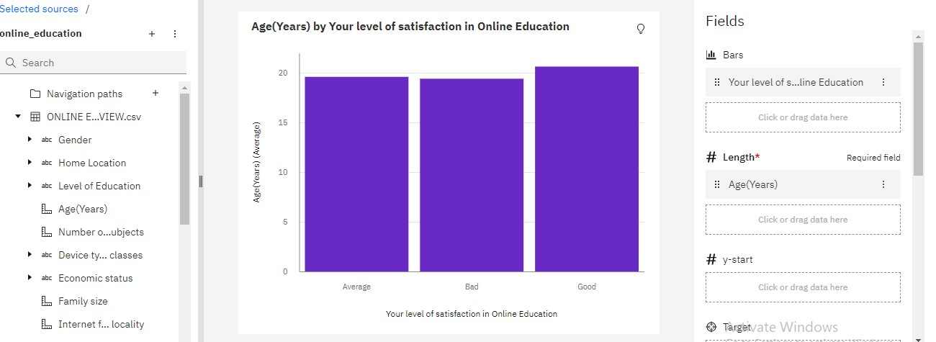

**Activity 1.2:Bar Chart:**

A bar chart can compare data across different categories, The height of the bars represents the measured value of each category. It can be represented as vertical and horizontal type bar charts.

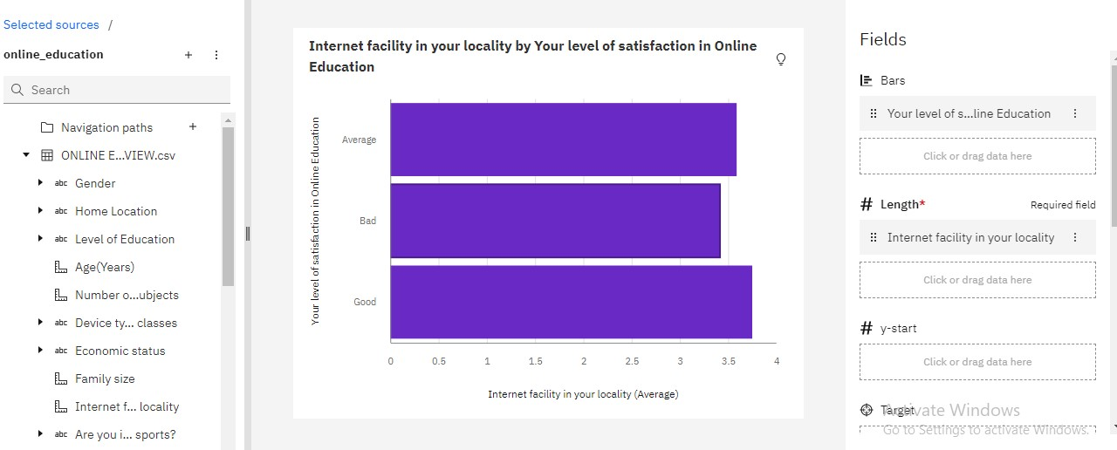

**Activity 1.3: Pie Chart:**

A pie chart can show the segment-wise data. It can show the contribution of measure over different members in a dimension. The angle of the pie determines the measured value.

Different colors can be assigned to pie to represent the members in a dimension.

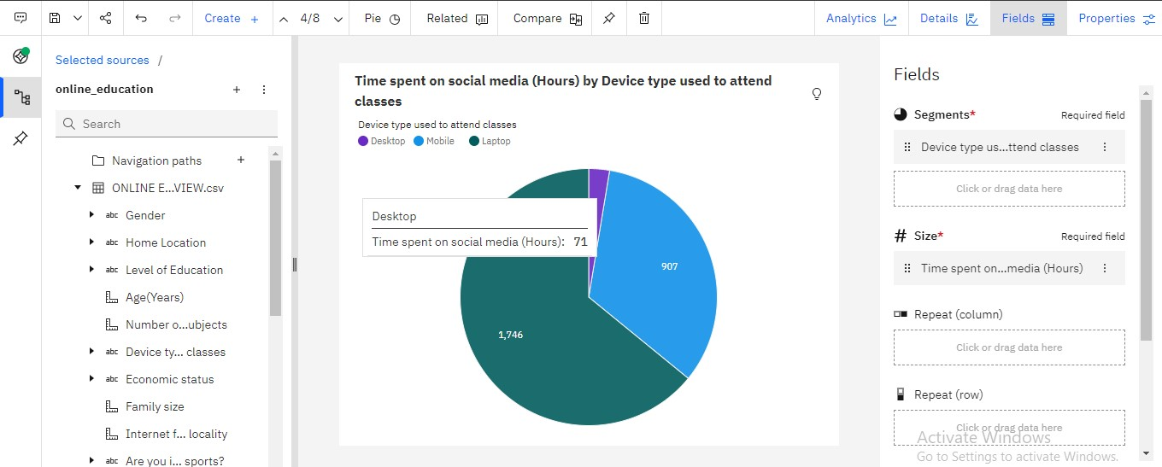

**Activity 1.4: Radial Chart :**

A Radial/Circular Bar Chart simply refers to a typical Bar Chart displayed on a polar coordinate system, instead of a cartesian system. It is used to show comparisons among categories by using a circular shape.

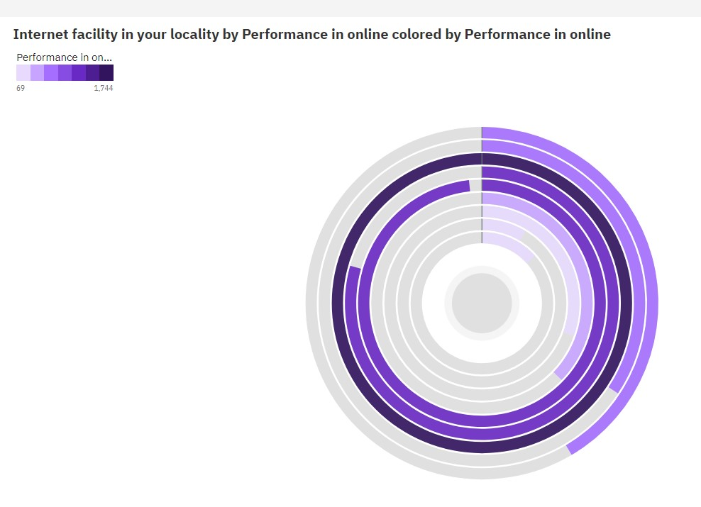

**Responsiveness And Design Of Dashboard**

The responsiveness and design of a dashboard for online education review data is crucial to ensure that the information is easily understandable and actionable. Key considerations for designing a responsive and effective dashboard include

user-centered design, clear and concise information, interactivity, data-driven approach, accessibility, customization, and security. The goal is to create a dashboard that is user-friendly, interactive, and data-driven,

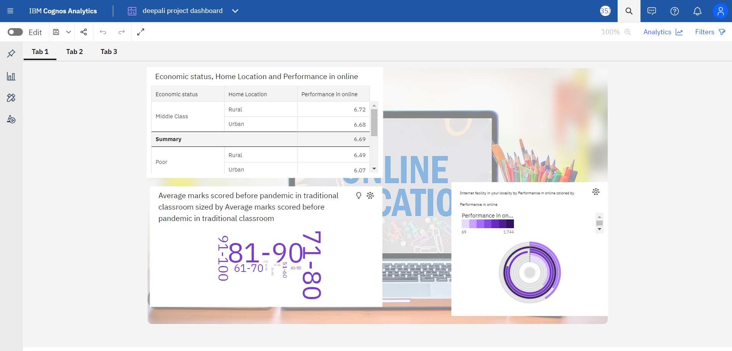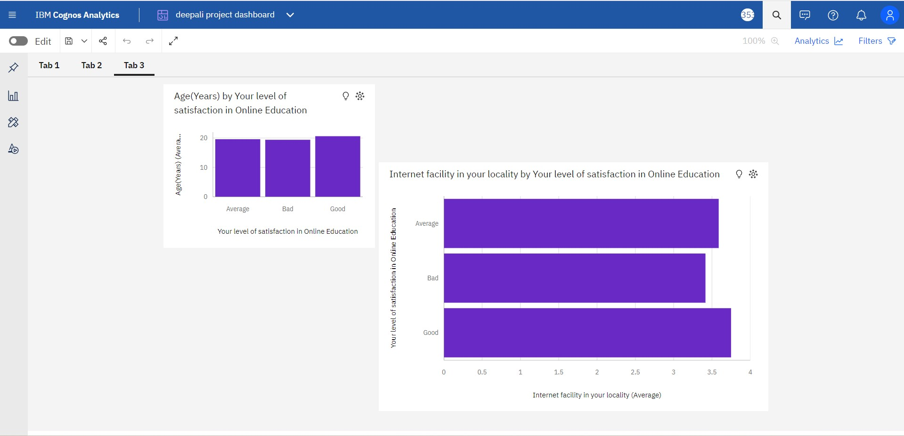

Story

A data story is a way of presenting data and analysis in a narrative format, with the goal of making the information more engaging and easier to understand. A data story typically includes a clear introduction that sets the stage and explains the context for the data, a body that presents the data and analysis in a logical and systematic way, and a conclusion that summarizes the key findings and highlights their implications. Data stories can be told using a variety of mediums, such as reports, presentations, interactive visualizations, and videos.

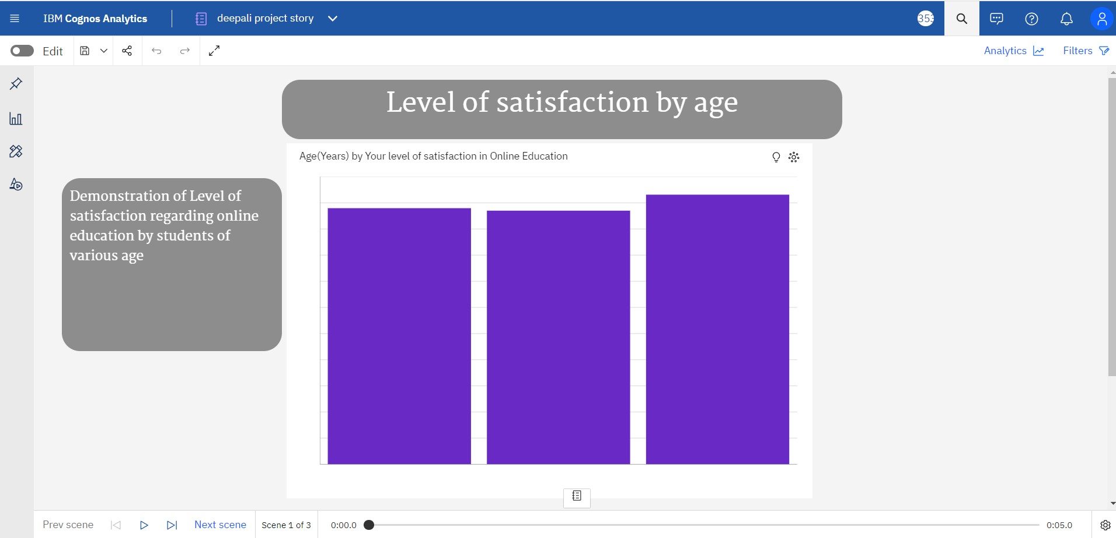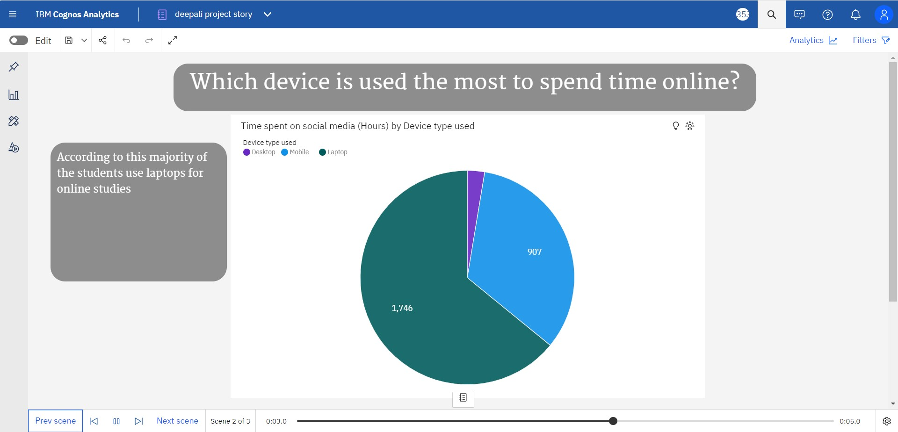

Report

A report is a document that presents information in a specific format and layout, usually based on data from a database or other data source. A report in IBM Cognos can contain various elements, such as tables, charts, graphs, and images, as well as text and data elements, and it is designed to be used by business users to help them better understand their data and make informed decisions. There are several different types of reports available in IBM Cognos, including list reports, crosstab reports, chart reports, and report studio reports, among others.

The type of report that you choose will depend on the specific needs and requirements of your organization, as well as the data that you need to present.

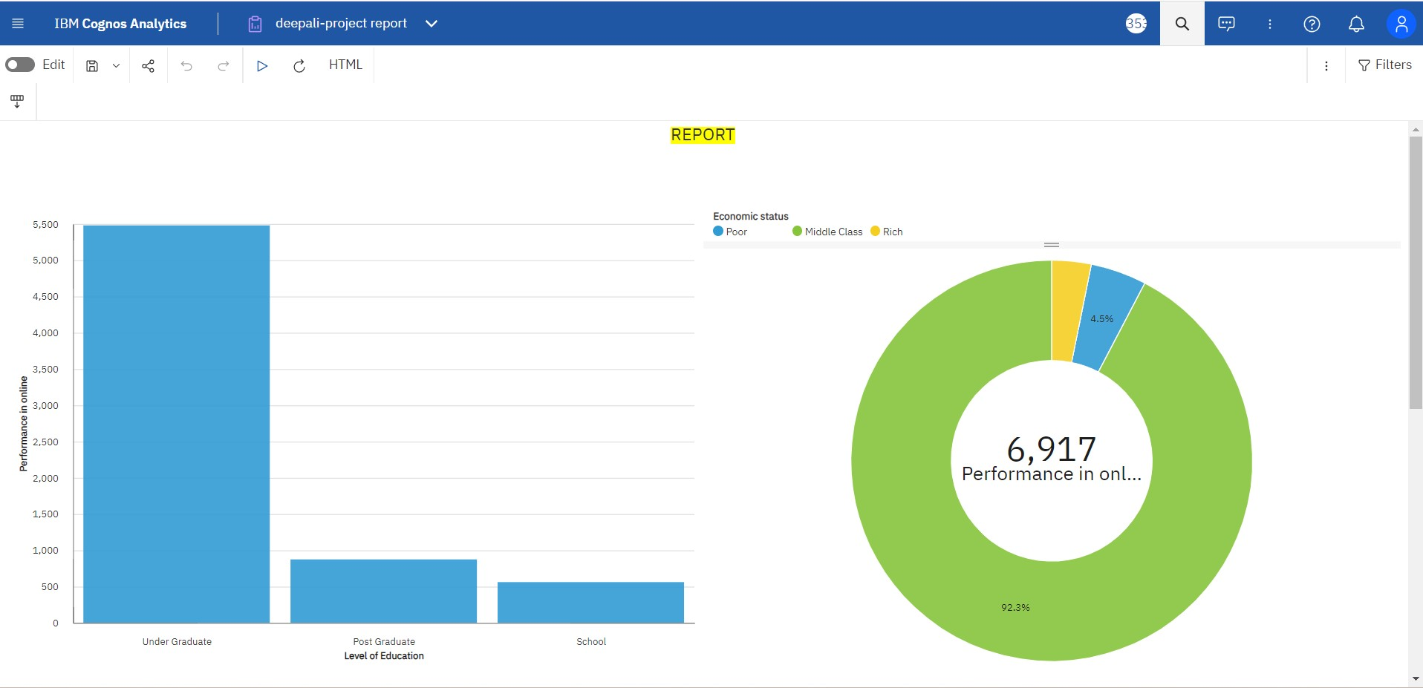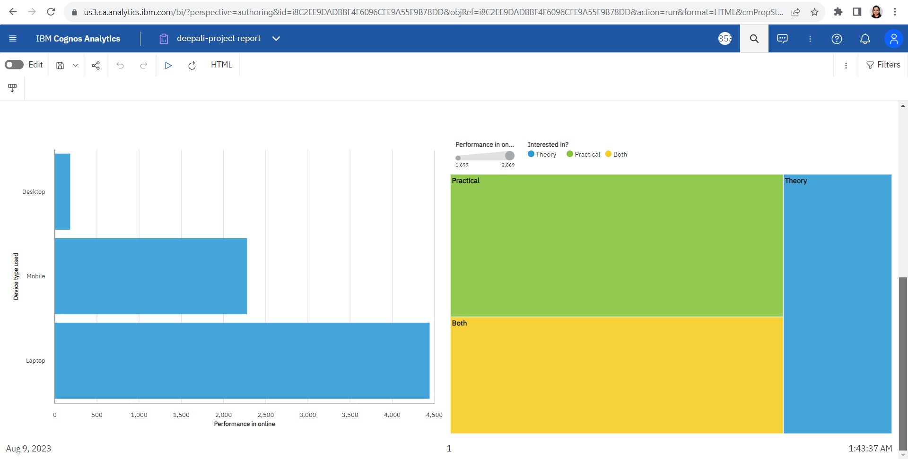

Performance Testing

Performance testing is a non-functional software testing technique that determines how the stability, speed, scalability, and responsiveness of an application holds up under a given workload.

**Utilization Of Data Filters**

* Data filters are used to customize our visualization to achieve desired output
* We can apply filters while building visualizations . In explorations, filters are present at bottom of the ‘Fields’ option



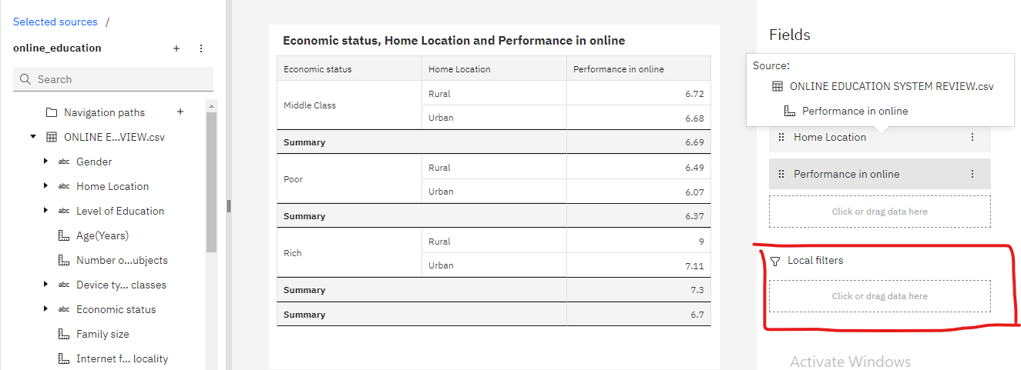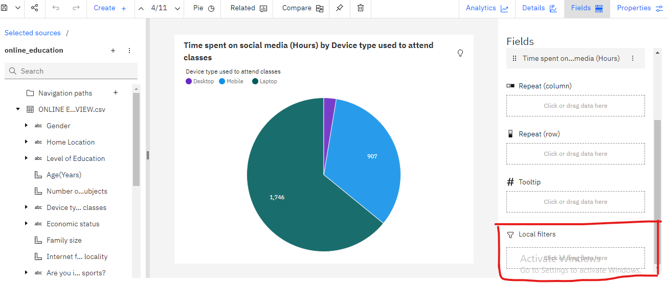

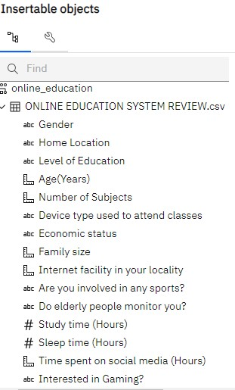

Web Integration

Publishing helps us to track and monitor key performance metrics, to communicate results and progress. help a publisher stay informed, make better decisions, and communicate their performance to others.

**Integrating dashboards/stories/reports to web**

step 1: Go to dashboard/story/report and click on share button on the top ribbon

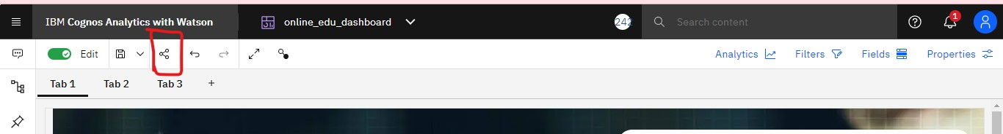

go to the ‘link’ option and copy the embed code

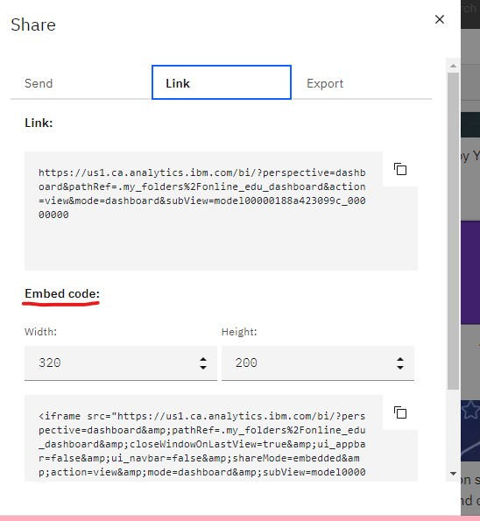

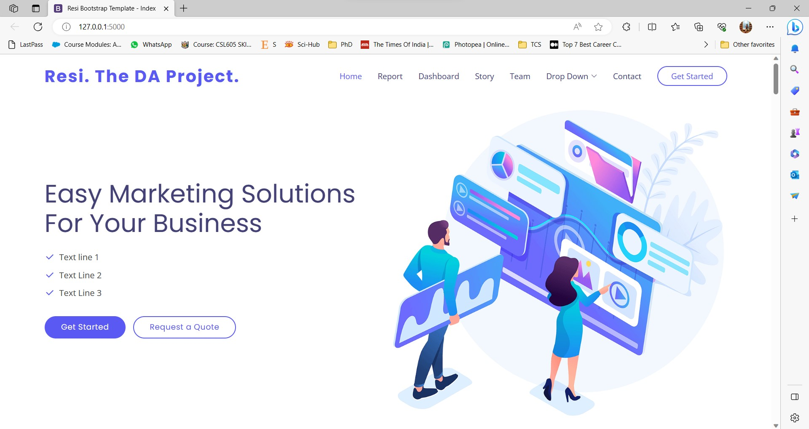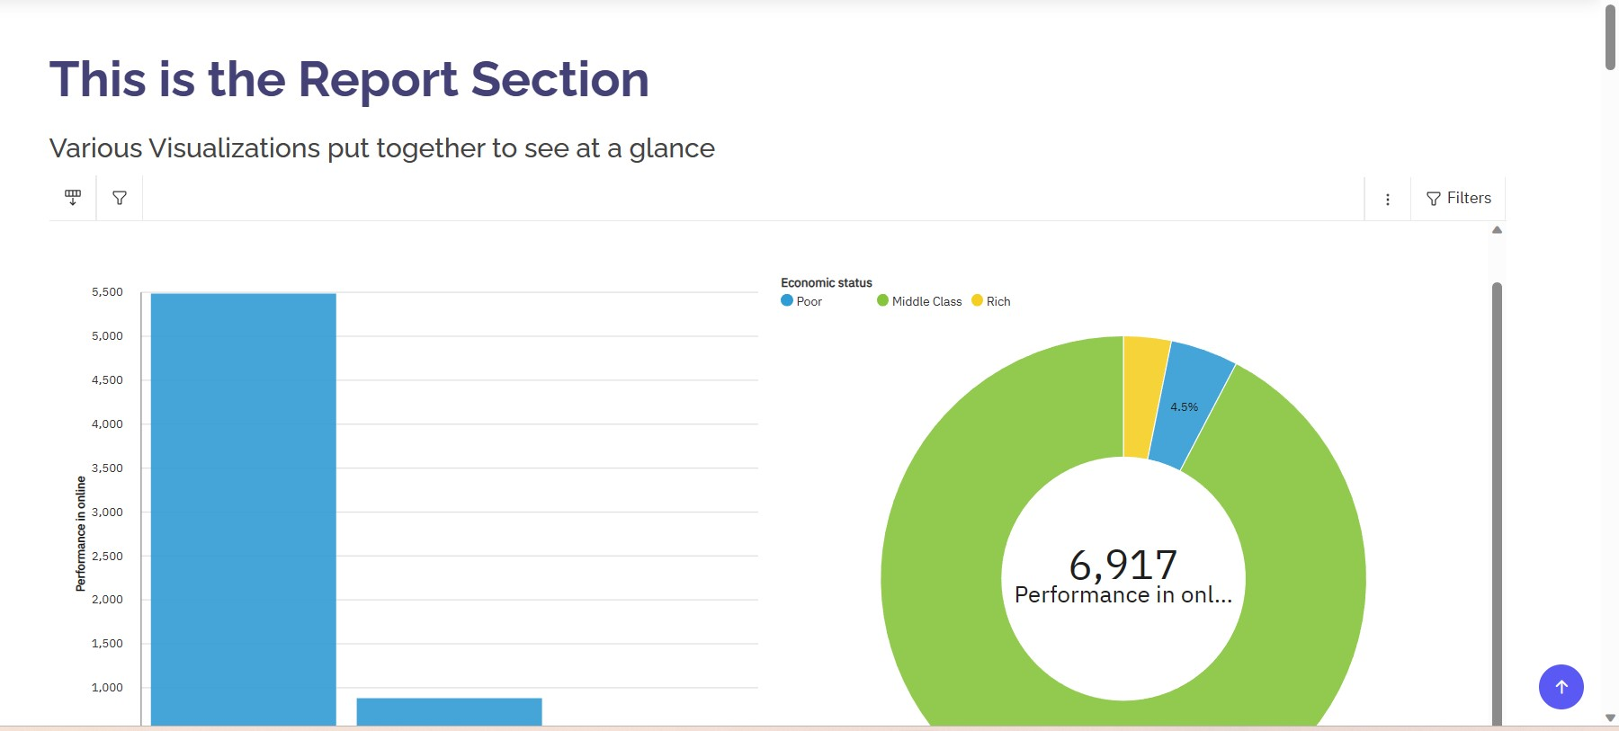

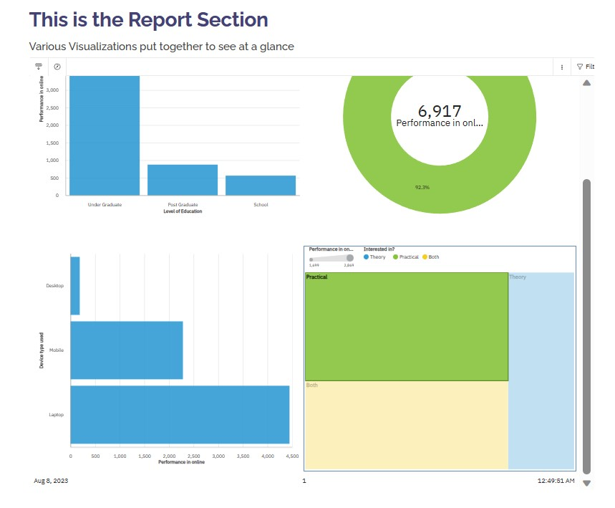

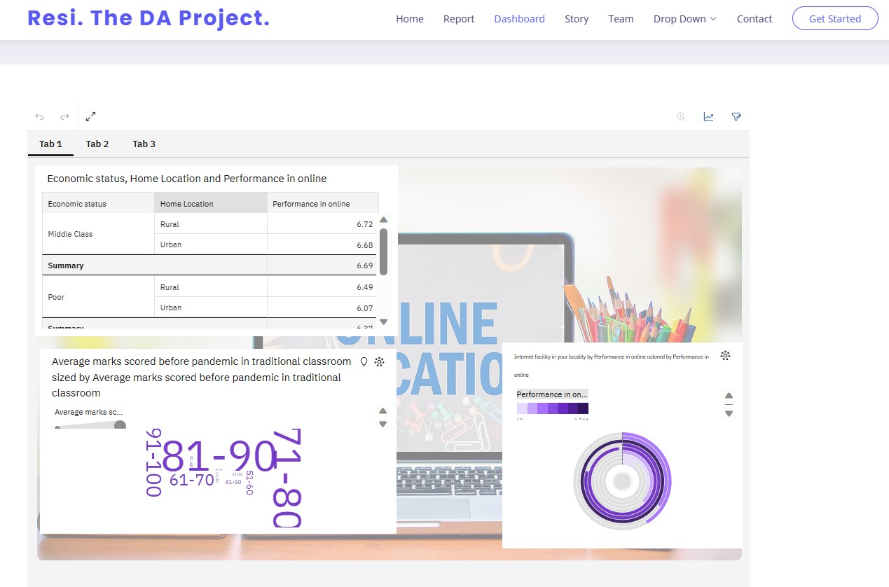

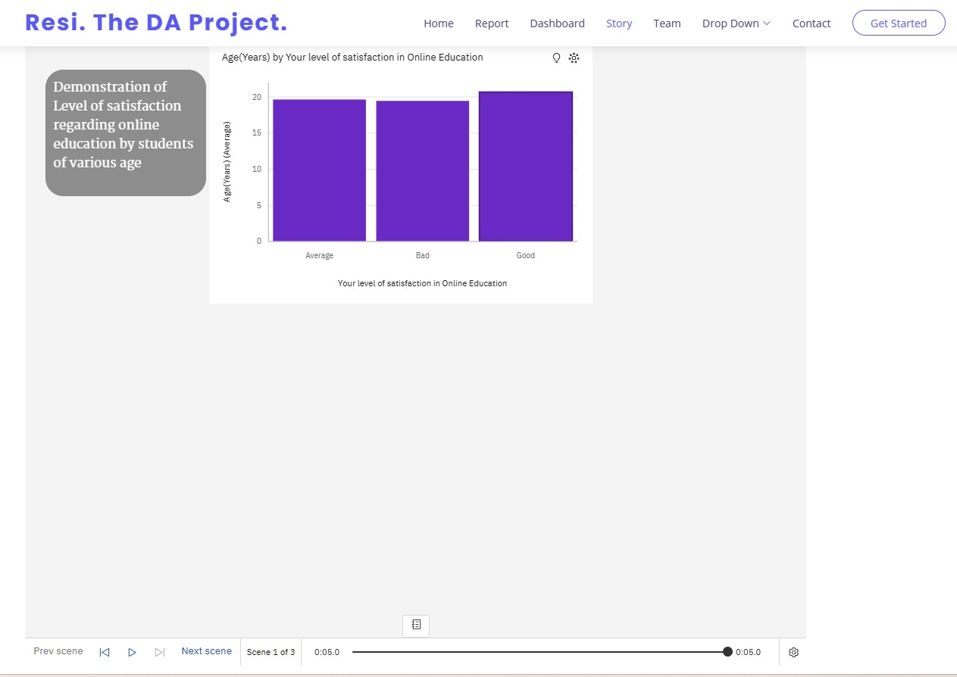

# Conclusion

Virtual Faculty Build-A-Thon is a project development activity where participants are enrolled in a project listed under distinct technology categories after acquiring crucial knowledge on the IBM cloud services and open source technologies in the Bootcamp. Thus, under this activity a project on IBM cognos was built where various data visualization and exploration was learnt. The dashboard, story and reports created in IBM cognos were integrated with the UI using flask in VS Code and run on the system localhost.